# Tracker, Calorimeter, or Cosmic Ray Veto or DAQ

## Introduction

The title of the chapter uses a *Heading 1* style. The Title of this subsection uses the *Heading 2* style. General text uses the normal style.

The introduction says what the detector does and describes the scope. This can be similar to the introduction in the CDR.

Use cross-references to point to references, tables and figures [1].

## Requirements

Discuss the overall requirements for the system. Reference the requirements documents on docdb, which you should have checked/updated.

* Use the List Paragraph style for bullets. Use bullets instead of numbers unless you specifically refer to the numbers.
* For the CRV, list the requirements for
  + Efficiency
  + Coverage
  + Time resolution
  + Etc.
* For the tracker discuss
  + Resolution
  + Timing
  + Rate requirements
  + Proton ID
  + Muon ID
  + Etc.
* For the calorimeter discuss
  + Resolution (energy, position, timing)
  + Particle ID
  + Rate requirements
  + Radiation hardness
  + Etc.
* For the DAQ discuss
  + Bandwidth requirements
  + Number of data sources
  + Timestamp
  + Control of live gate
  + Calibration and diagnostic modes
  + Slow controls
  + Etc.

## Technical Design

Describe the basic design and technology for the detector. In the subsections that follow, describe the mechanical design, electronics, power, cooling, etc. This should be fairly exhaustive with lots of drawings, tables, calculations and references to technical notes. Include discussion of safety factors, interfaces, value engineering and risk mitigation.

### Technical Design Subsection

### Technical Design Subsection

### Technical Design Subsection

### Cosmic Ray Veto System Parameters

Include a table like this for your system that lists all of the relevant parameters.

## Performance

Describe the performance of the design. Again, this should be fairly exhaustive.

### Calibration

Describe how you will calibrate the detector (not relevant to DAQ).

Table .. Cosmic Ray Veto system parameters.

|  |  |
| --- | --- |
| Scintillator layers | 3 |
| Scintillator counter size | 4.700 × 0.100 × 0.010 m3 |
| Module size | 4.766 × 1.241 × 0.041 m3 |
| Total number of modules | 58 |
| Total module active area | 330 m2 |
| Counter (module) mass | 4.982 (328) kg |
| Counters per module | 36 |
| Total number of counters | 2088 |
| Total counter length | 9814 m |
| Total scintillator mass | 10,402 kg |
| Fiber diameter | 1.0 mm |
| Fibers per counter | 4 |
| Total number of fibers | 8352 |
| Total fiber length | 40,925 |
| Fibers per SiPM | 1 |
| Fiber ends read out | 2 |
| Readout channels per module | 288 |
| Front-end boards per module | 6 |
| Total number of channels (SiPMs) | 16,704 |
| Total number of front-end boards | 348 |
| Total number of readout controllers | 15 |

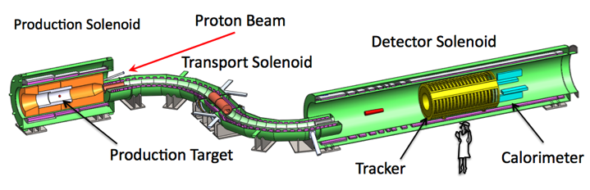

Figure . The Mu2e apparatus.

Don’t worry too much about figure placement. They will move around. I’ll fix their final position in the final draft.

## Risks

Describe remaining risks.

## Quality Assurance

Describe how you will ensure that the detector is built to specification.

## Installation and Commissioning

Describe how the detector will be installed and commissioned.

## References

1. W. Bertl et al., Eur. Phys. J. **C47**, 337 (2006).